**0EECS 495 Accessible Software System Design**

**“A Day At The Dentist Is The Best Kind Of Day” Requirements Document**

**Group members: Khalil Crawford (kkjcraw), Seungyoun Lee (seungy), Ritsuma Inaba (rinaba), Jacob Sturgis (jsturg)**

**System Description**

**System Purpose:**

Children with autism spectrum disorder (ASD) follow routines everyday in order to fully adjust to environments or new tasks. However, many children with ASD have trouble adjusting to their dental appointments, because they only go twice a year normally and the process is not part of their everyday routine. It may take a long amount of time and possibly several appointments for children to ASD to become adjusted to the environment. The project’s focus is to desensitize children with ASD by having them explore and interact a dental office using mixed reality headsets. The goal of the project is to see if mixed reality environments, when used by children with ASD, improve their quality of life in many unfamiliar areas, such as hospitals and new schools.

**Project Scope:**

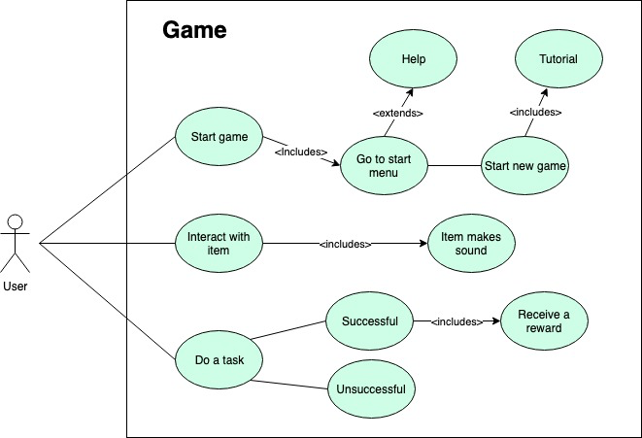

Once the game is started by the user, the user is directed to the start menu. Once the user is in the start menu, the user have two options. The user can go to the help screen, which includes the controls needed to play the game, or the user can start the game. After starting the game, the user will first go through a tutorial to get used to moving the character in the virtual reality environment.

Inside the game, the user is able to interact with an item. Whether the user picks up an item or uses the item, some kind of sound will accompany the users action. They can also complete a task within the game. The user receives a reward only when the task is successfully completed.

**Project Flow (Sequence Diagram(s))**:

Expected Usage:

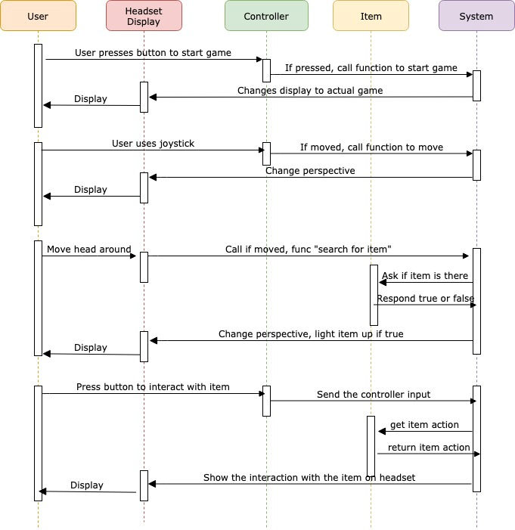

This is a sequence diagram representing a scenario that we expect the user to go through. The user can first select the start button in the start menu using the controller. After the button is pressed the system should process the call and display the dentist room on the headset. Once the user sees the virtual reality environment, the user can move the joystick to change the view. The system should correctly handle the controller input and change the scenery displayed on the headset.

While the user moves his/her head, a function is called to see if there is an item the user can interact with in the position that the user move the head. If there is an item, the system should make the item light the item up to notify the user that the item can be interacted with. Once the user see the item, they can interact with the item using the controller. The system will look up the item and retrieve the action related with the item. Once it retrieved the action, it will display the character interact with the item on the headset.

Unexpected Usage:

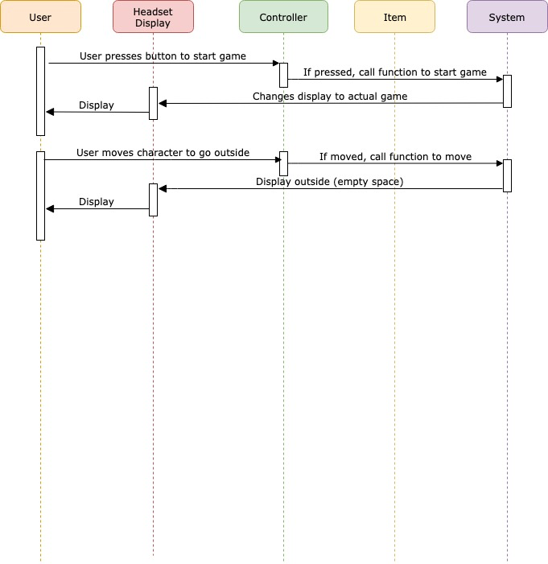

This sequence diagram represents a scenario where the user somehow gets outside of the dental building. After the user successfully start the game through the start menu, the user uses the controller to move outside of the building. After the character moves outside, the system displays the scenery outside the building to the headset.

This will be a problem for our project because we don't have any outside scenery designed in the game. The user will see a building floating in empty space from the outside.

**Enumeration of Requirements:**

| DAY-N1 | Target Audience: Children With ASD | non-func | α,β,Ω |
| --- | --- | --- | --- |
| Description: The product is targeted towards children with autism spectrum disorder | | | |
| Source: Clients | | | |
| Notes: | | | |

| DAY-N2 | Working With The Clients | non-func | α,β,Ω |
| --- | --- | --- | --- |
| Description: Take into account ideas, thoughts, reviews from clients | | | |
| Source: Clients | | | |
| Notes: Clients meet up with the team during class | | | |

| DAY-N3 | Feedback From Class Staff | non-func | α,β,Ω |
| --- | --- | --- | --- |
| Description: Gain feedback from class staff about the project | | | |
| Source: Dr. Chesney | | | |
| Notes: | | | |

| DAY-N4 | Purchased Assets | non-func | α |
| --- | --- | --- | --- |
| Description: Purchase pre-existing assets from the Unity Asset Store, as the team does not have experience with creating 3D models | | | |
| Source: Project Team | | | |
| Notes: | | | |

| DAY-N5 | Setting When Using The Product | non-func | α |
| --- | --- | --- | --- |
| Description: The user must use the product with the Acer headset plugged into a PC | | | |
| Source: Project Team | | | |
| Notes: | | | |

| DAY-N6 | Alpha Release Date | non-func | α |
| --- | --- | --- | --- |
| Description: The Alpha version must be released on 2/28 | | | |
| Source: Dr. Chesney | | | |
| Notes: | | | |

| DAY-N7 | Powerful PC with Graphics Card | non-func | α |
| --- | --- | --- | --- |
| Description: The project needs a PC with a graphics card with these specs: Nvidia GTX 960/965M/1050 or AMD RX 460 and above to run the Acer Mixed Reality headset | | | |
| Source: Project Team | | | |
| Notes: One team member has a desktop that will be using to demo and test the project | | | |

| DAY-N8 | Audio Files From Internet | non-func | α |
| --- | --- | --- | --- |
| Description: The audio files used in the game are from the internet, as the team doesn’t have access to record the actual dental tools | | | |
| Source: Project Team | | | |
| Notes: | | | |

| DAY-F1 | Setting Creation | func | α |
| --- | --- | --- | --- |
| Description: The setting is a realistic dental room designed in Unity | | | |
| Source: Client | | | |
| Notes: Use the purchased assets | | | |

| DAY-F2 | Change User Position | func | α |
| --- | --- | --- | --- |
| Description: User can change their position in the environment | | | |
| Source: Client | | | |
| Notes: | | | |

| DAY-F3 | First-Person View | func | α |
| --- | --- | --- | --- |
| Description: The users perspective is from the First-Person | | | |
| Source: Client | | | |
| Notes: | | | |

| DAY-F4 | Grabbable Dental Tools | func | α |
| --- | --- | --- | --- |
| Description: User can pick up dental tools | | | |
| Source: Client | | | |
| Notes: The tool is positioned in front of the user when picked up | | | |

| DAY-F5 | Object Sounds | func | α |
| --- | --- | --- | --- |
| Description: The object triggers a sound when the tools are picked up | | | |
| Source: Client | | | |
| Notes: For sounds one would hear at the dentist (drills, suction, etc.) | | | |

| DAY-F6 | Help Screen | func | α |
| --- | --- | --- | --- |
| Description: Create a help screen with a list of controls | | | |
| Source: Project Team | | | |
| Notes: | | | |

| DAY-F7 | Start Menu | func | α |
| --- | --- | --- | --- |
| Description: Create a start menu | | | |
| Source: Project Team | | | |
| Notes: Link to either the game or the help screen | | | |

| DAY-F8 | Change User View Orientation | func | α |
| --- | --- | --- | --- |
| Description: User can rotate the headset to change the orientation of their view | | | |
| Source: Project Team | | | |
| Notes: | | | |

| DAY-F9 | Compatible With Acer Mixed Reality Headset | func | α |
| --- | --- | --- | --- |
| Description: Game to be compatible with Acer Mixed Reality headset | | | |
| Source: Dr. Chesney | | | |
| Notes: | | | |

| DAY-F10 | Compatible with Acer Mixed Reality Controllers | func | α |
| --- | --- | --- | --- |
| Description: Game to be compatible with the Acer Mixed Reality controllers | | | |
| Source: Dr. Chesney | | | |
| Notes: | | | |

| DAY-N9 | Beta Release Date | non-func | β |
| --- | --- | --- | --- |
| Description: The Beta version must be released on March 26th | | | |
| Source: Dr. Chesney | | | |
| Notes: | | | |

| DAY-F11 | More Cosmetic Changes | func | β |
| --- | --- | --- | --- |
| Description: Add cosmetic changes, such that it resembles more of a dental office | | | |
| Source: Clients | | | |
| Notes: | | | |

| DAY-F12 | Tasks/Objectives | func | β |
| --- | --- | --- | --- |
| Description: Objectives for the user to complete in order to progress through the game dealing with items and procedures in the dental office | | | |
| Source: Clients | | | |
| Notes” | | | |

| DAY-F13 | Adjustable volume settings | func | β |
| --- | --- | --- | --- |
| Description: User can change the audio volume of the dental tools | | | |
| Source: Clients | | | |
| Notes: | | | |

| DAY-F14 | Vibration in the objects | func | β |
| --- | --- | --- | --- |
| Description: The object vibrates when the user picks up a tool | | | |
| Source: Project Team | | | |
| Notes: | | | |

| DAY-F15 | Scoring/Backpack Feature | func | β |
| --- | --- | --- | --- |
| Description: The user receives points whenever they finish a task, for which they can spend on items for their “Backpack” | | | |
| Source: Clients | | | |
| Notes: | | | |

| DAY-N10 | Omega Release Date | non-func | Ω |
| --- | --- | --- | --- |
| Description: The Omega version must be released on April 23 | | | |
| Source: Dr. Chesney | | | |
| Notes: | | | |

| DAY-F16 | Voiceovers | func | Ω |
| --- | --- | --- | --- |
| Description: Many interactions and objectives will have a voiceover | | | |
| Source: Project Team | | | |
| Notes: | | | |

| DAY-F17 | “Choose Your Own Path” | func | Ω |
| --- | --- | --- | --- |
| Description: The user will have a choice between two options. These options lead to different outcomes | | | |
| Source: Project Team | | | |
| Notes: | | | |

**Prototype User Interface**

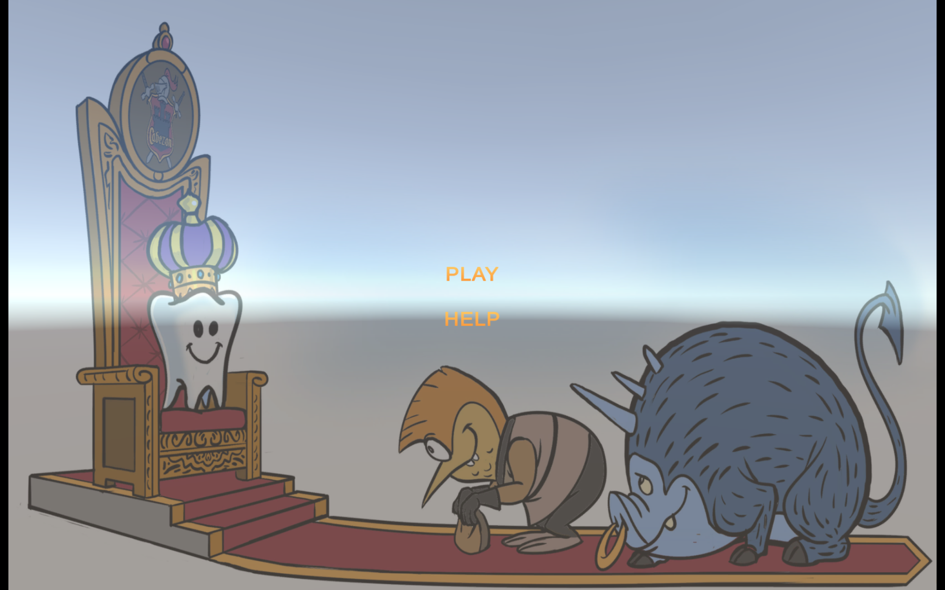

This is the start menu. Once the user starts the game, the user will be directed to this screen. Using the controller, the user can either choose to go to the help screen or start a new game.

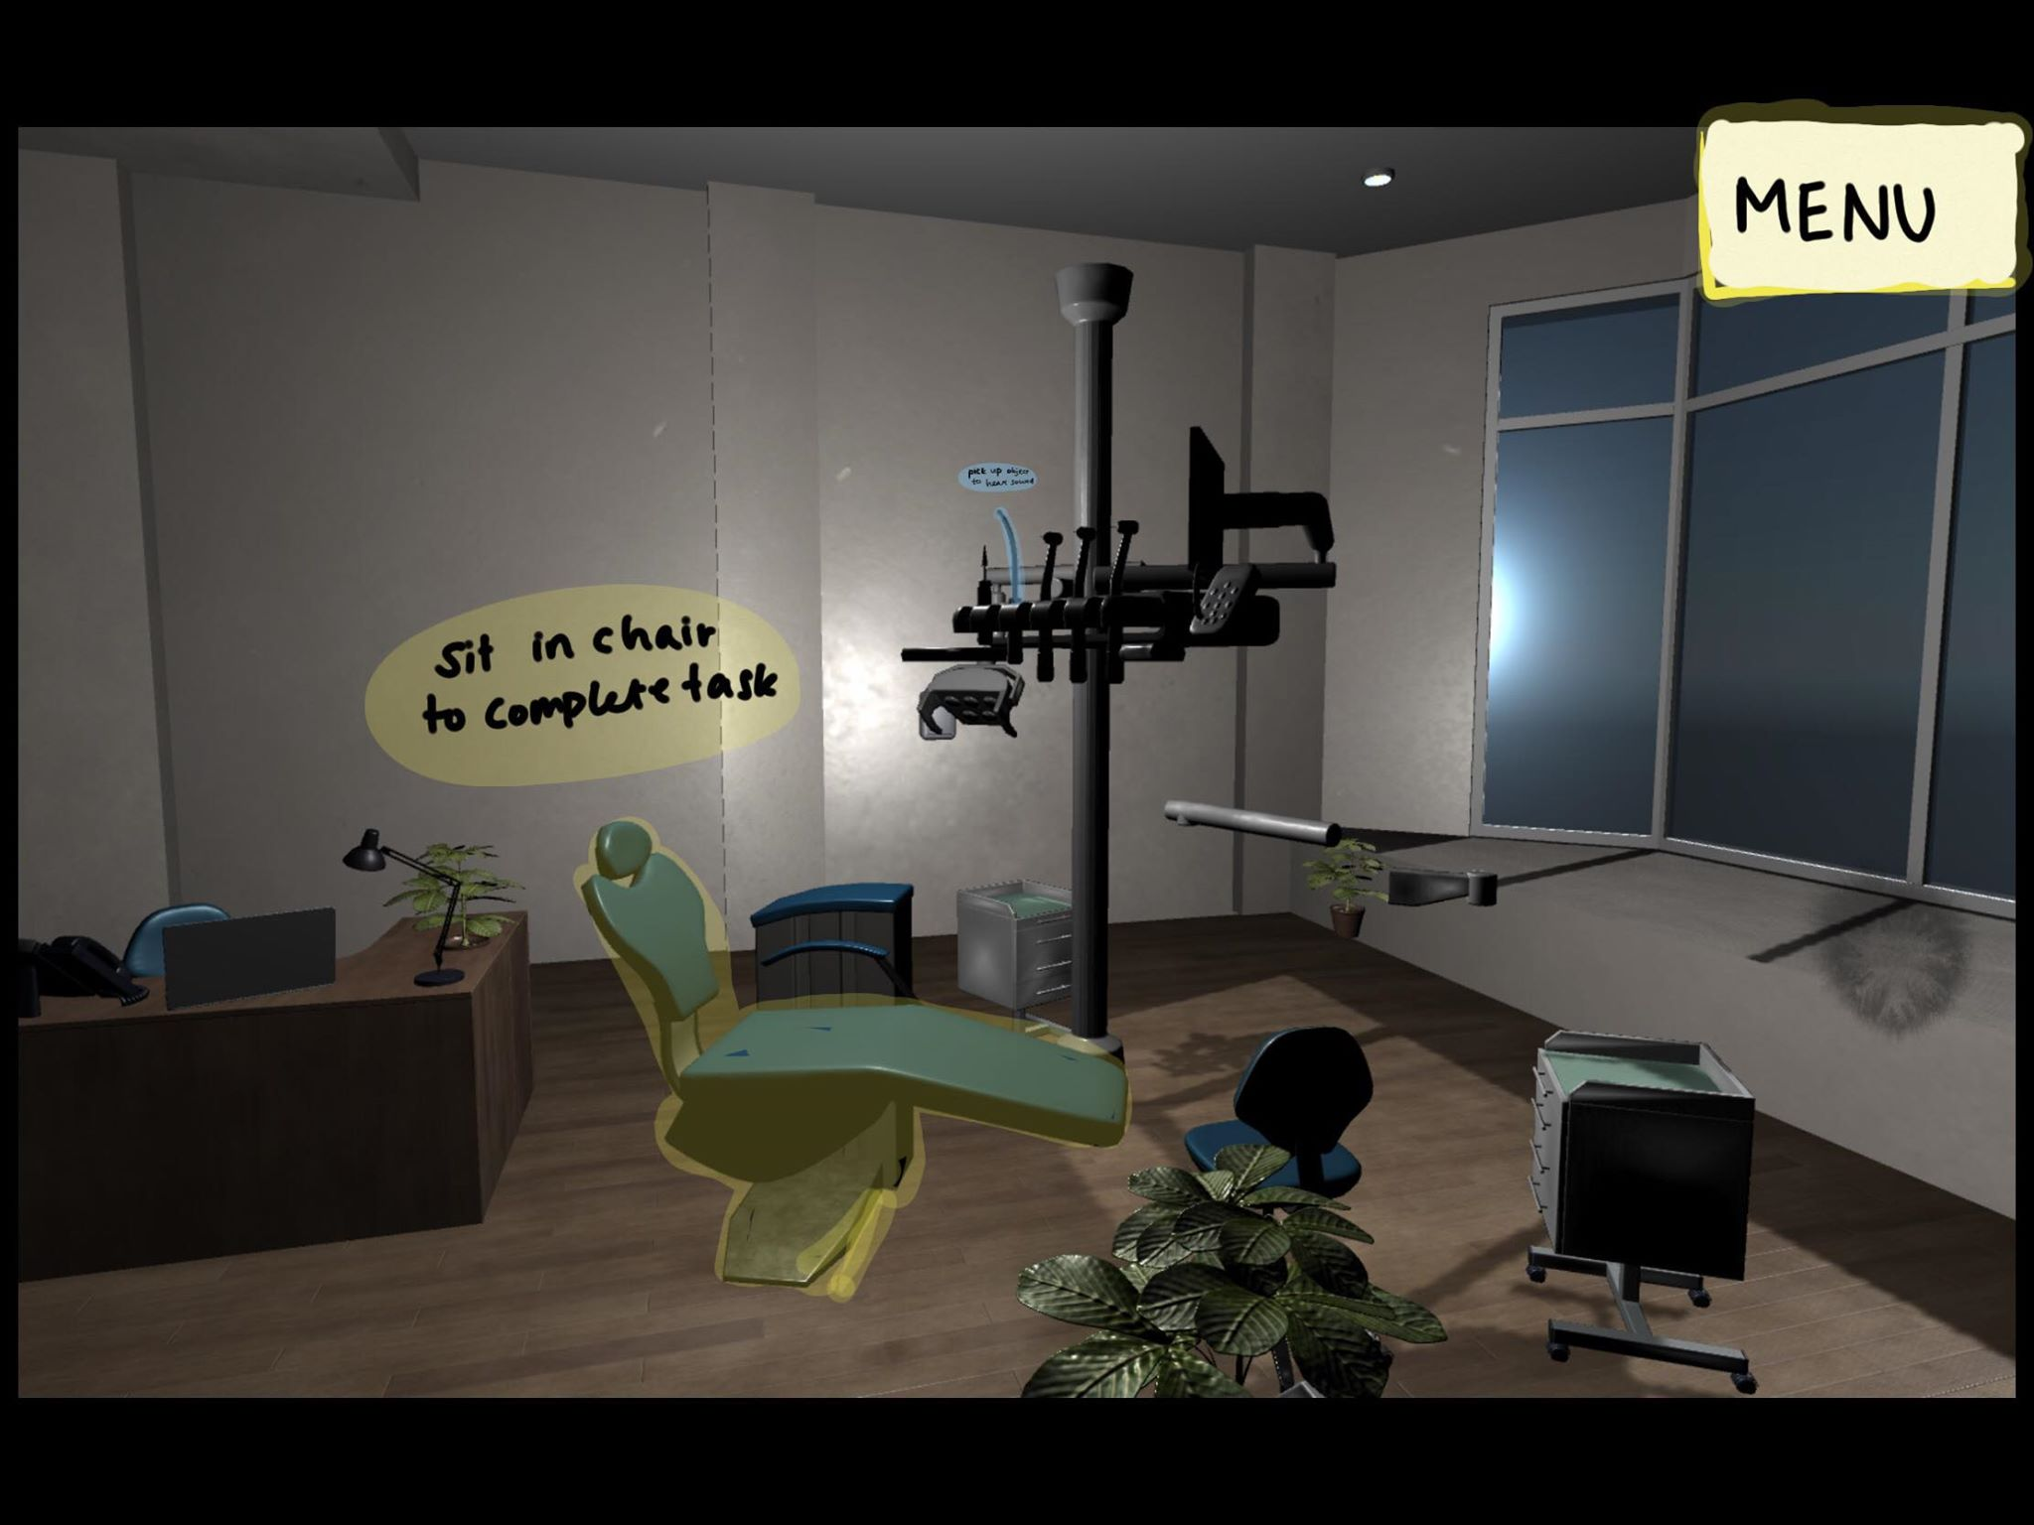

The picture above is an accurate setting of what the user will interact with, which includes the chair the user will sit in and on the desk. There is a tool that the user can pick up using the Acer mixed reality controllers. Once the tool is picked up a sound will trigger, and in the Beta release, the user will be able to adjust the volume. There are few things we will add to our game to make it more User-Friendly, such as the addition of directions for each task in the form of text and voice, and the illumination of items once close, telling the user that the item can be picked up. The functionality to exiting the game to main menu and the functionality to receive help will be added to the Beta release.

**Environment Description**

The team is working on Unity to develop the project. The VR development platform in Universal Windows 10 is being used, because the target environment of our project is with the Acer Mixed Reality Headset. Packages that will be used to development include the “Dental Room” package found on the Unity Asset Store. Audio files of the dental tools will be attached to each object in the game.

**References**

FusedVR, director. *Getting Started with Windows "Mixed Reality" Toolkit ( Unity 2017 VR Tutorial )*. *YouTube*, FusedVR, 17 Feb. 2018, [www.youtube.com/watch?v=PV8ycLfXFyM&t=584s](http://www.youtube.com/watch?v=PV8ycLfXFyM&t=584s).

“Getting Started with VR Development.” *Unity Tutorials*, Unity, unity3d.com/learn/tutorials/topics/xr/getting-started-vr-development.

Turner, Alex. “Unity Development Overview - Mixed Reality.” *Microsoft Docs*, Microsoft, 20 Mar. 2018, docs.microsoft.com/en-us/windows/mixed-reality/unity-development-overview.

Wester, Matt, director. *Pick up and Move Objects | Unity 2017 Tutorial*. *YouTube*, YouTube, 5 Sept. 2017, www.youtube.com/watch?v=JtflOvhOO1Y.